Special Topics Hands on Genome Assembly Raw Documentation
- Data upload:
For data, I uploaded the following URLs and ensured datatype was fasta:
https://zenodo.org/record/6098306/files/HiFi_synthetic_50x_01.fasta
https://zenodo.org/record/6098306/files/HiFi_synthetic_50x_02.fasta
https://zenodo.org/record/6098306/files/HiFi_synthetic_50x_03.fasta

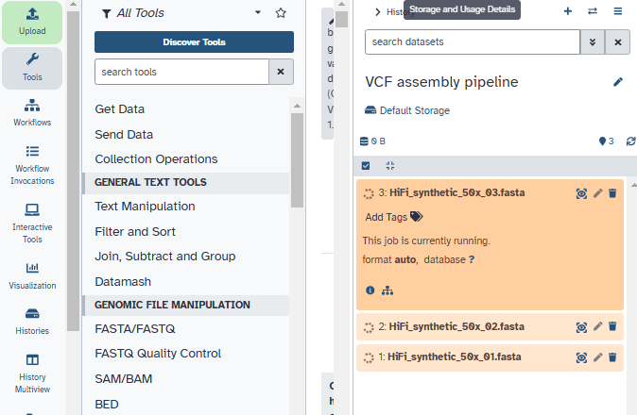
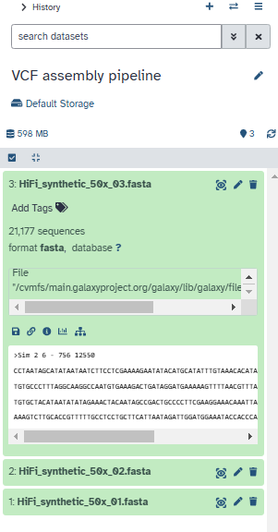
Completed

Then I uploaded the following Hi-C datasets, their dataypes were fastqsanger.gz:
https://zenodo.org/record/5550653/files/SRR7126301_1.fastq.gz
https://zenodo.org/record/5550653/files/SRR7126301_2.fastq.gz
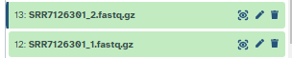
They were renamed:
SRR7126301_1.fastq.gz as Hi-C_dataset_F for the forward reads, and SRR7126301_2.fastq.gz as Hi-C_dataset_R for the reverse reads.
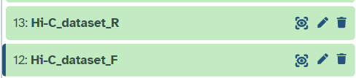

Data was organised as specified in the tutorial:
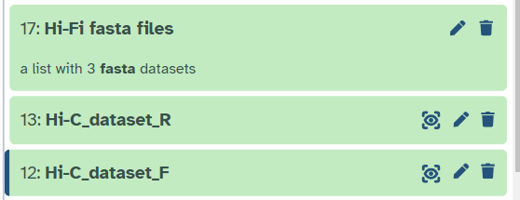

- Cutadapt:
Hi-Fi reads were preprocessed using cutadapt. If any read was found to have an adapter, cutadapt was used to remove it entirely instead of trimming it and retaining it.
These are the adapter sequences I filtered for:
1st: ATCTCTCTCAACAACAACAACGGAGGAGGAGGAAAAGAGAGAGAT
2nd: ATCTCTCTCTTTTCCTCCTCCTCCGTTGTTGTTGTTGAGAGAGAT
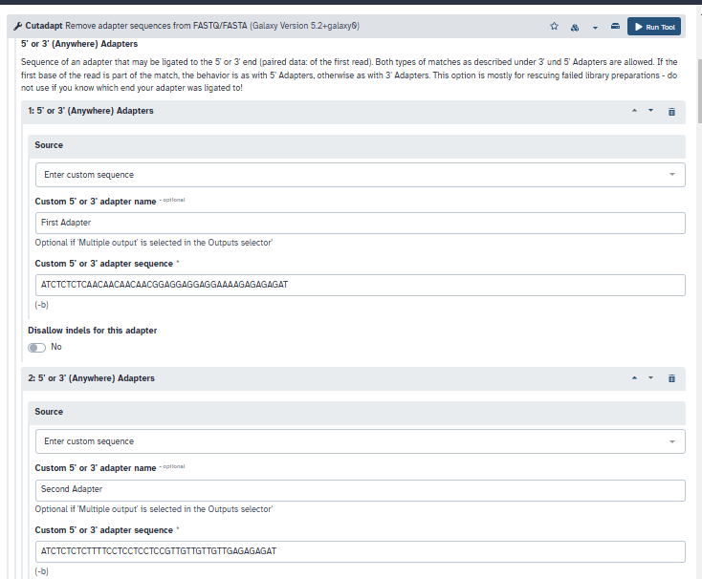
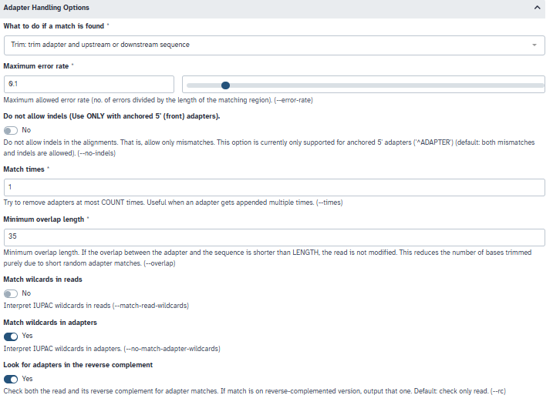
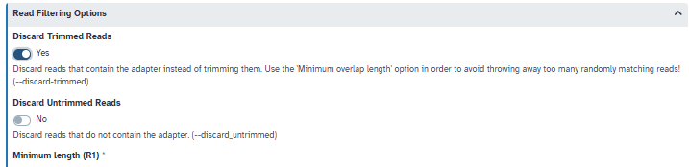
Over here, we selected yes for discarding trimmed reads as we don’t want low quality reads.
Output: 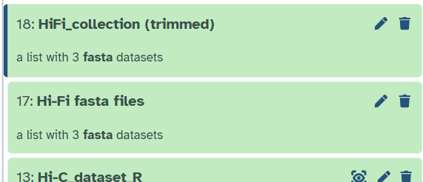

- Genome profile analysis using Meryl:
K-mer count distributions (histogram?) can be generated using meryl which involves calculating ideal k-mer sizes (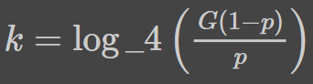, where G is the genome size, and p is a tolerable collision rate), decomposing the sequencing data into k-mers, counting the occurrence of each k-mer and determining its frequency.

K-mer counting is done on the collection of fasta files as indicated in the image:
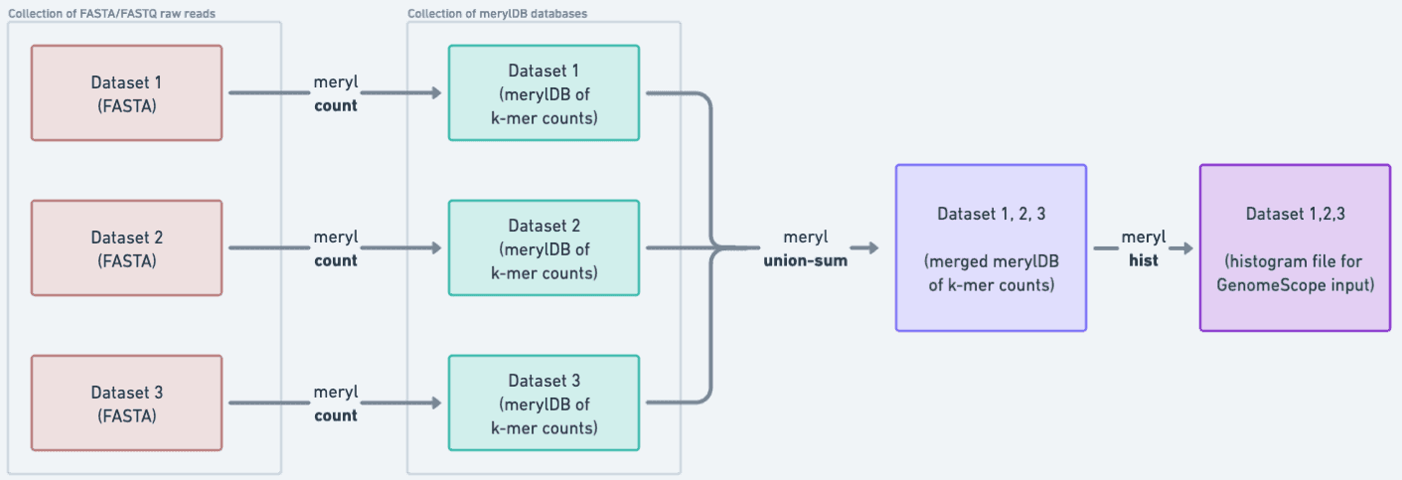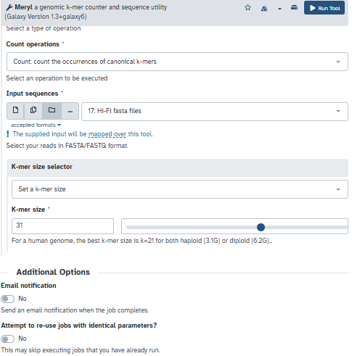
K-mer size was set to 31 as “in the case of the human genome, k-mers of 31 bases in length lead to 96.96% of unique k-mers.”
Output:
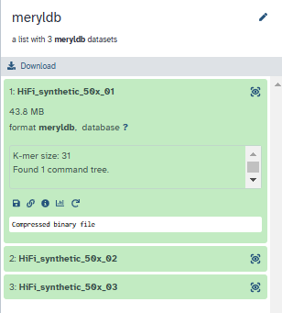

Meryl was run again, with the meryldb collection as input. Output is renamed to Merged meryldb:

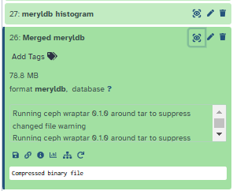
Meryl is run a third time with Merged meryldb as input. Histogram is generated:

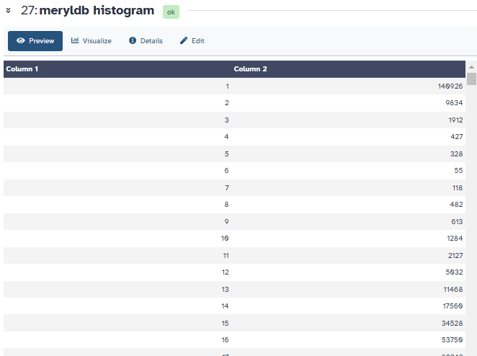
Here is the histogram visualised using plotly:
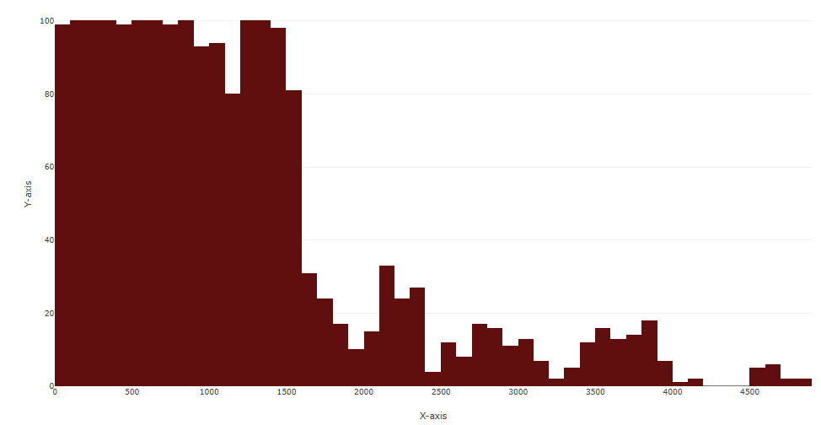
- GenomeScope:
Genome properties were inferred using GenomeScope using the meryldb histogram as input. Ploidy was set to 2 and k-mer length was set to 31 for consistency.

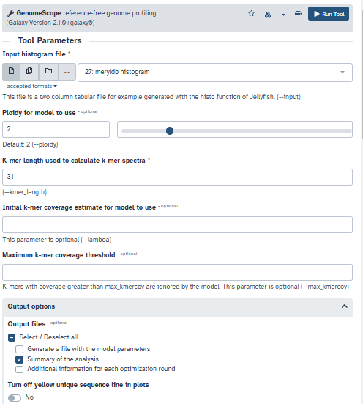
These were the outputs:
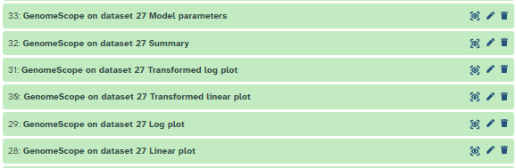
Linear plot:
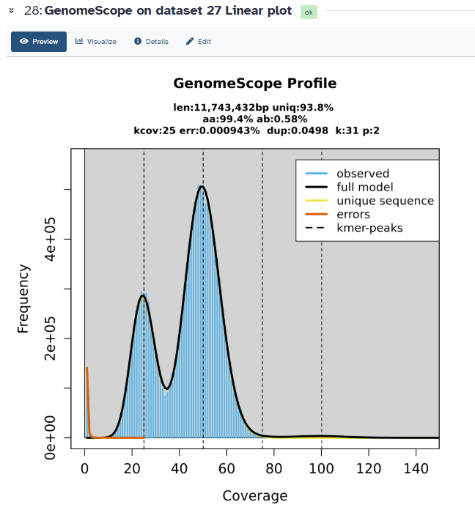
logplot:
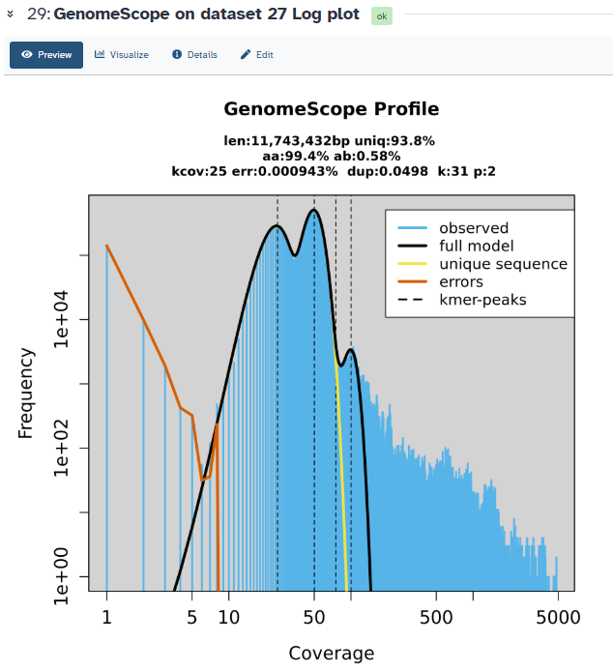
Transformed linear plot:
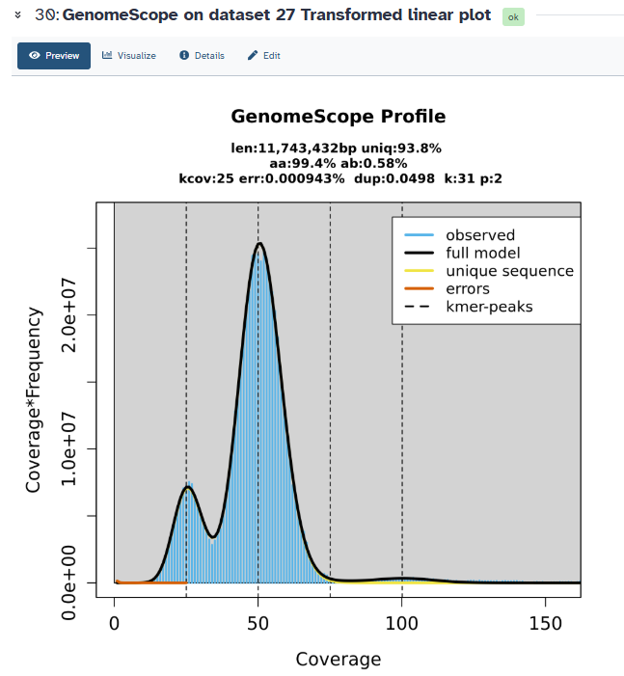
Transformed log plot:
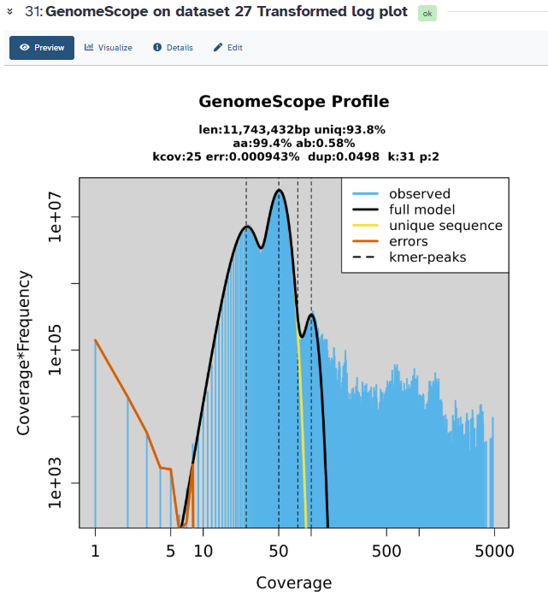
Summary:
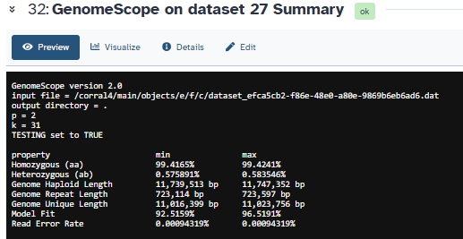

- Hifiasm:
I chose Hi-C mode
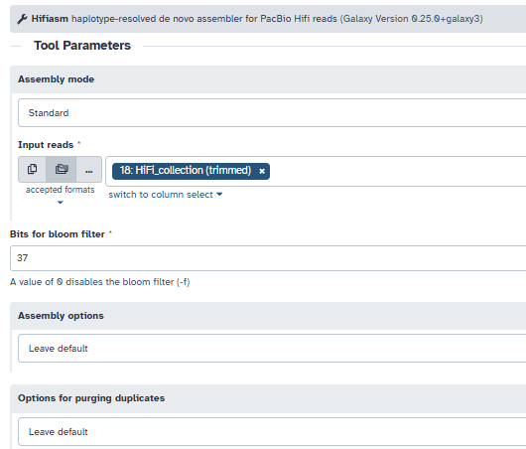
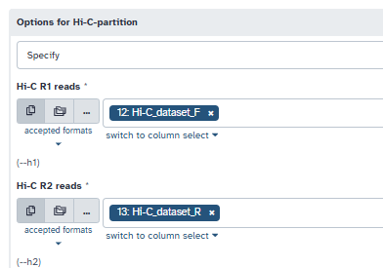

Here is the output:
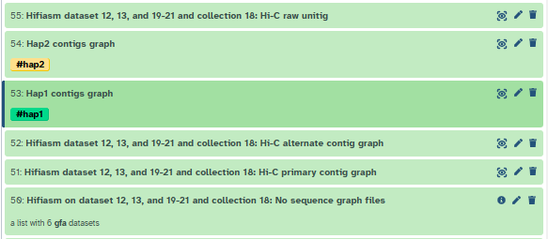
(the tags were added manually)

- Conversion from GFA to FASTA using gfastats
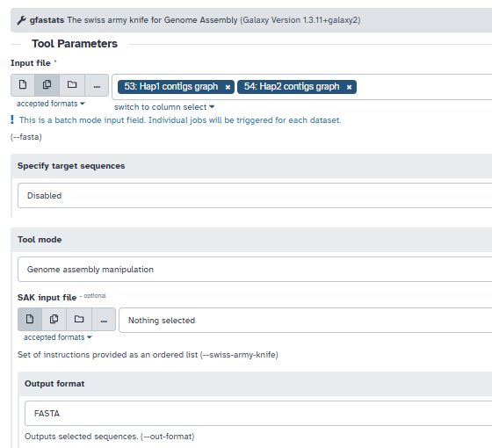
Output:
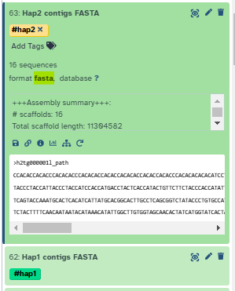

- Assembly evaluation using gfastats - generating stats:
I added the following genome size: 11743432 (this was calculated using GenomeScope, it is slightly different from the tutorial which had an expected genome size of 11747160).

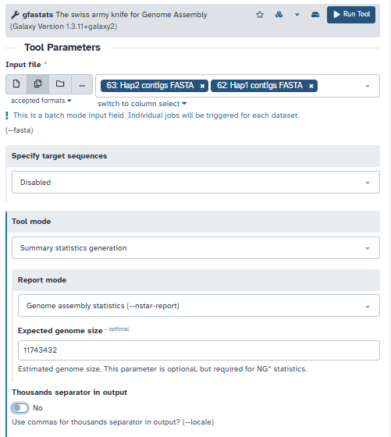
Output:
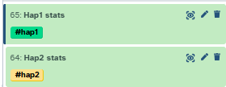

- Column join to merge the gfastats outputs:
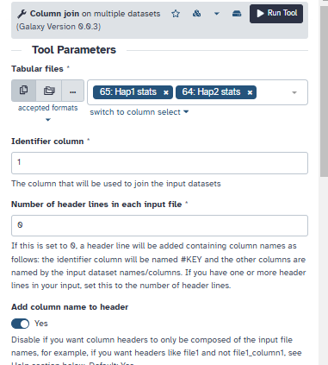
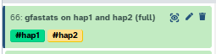
Preview:
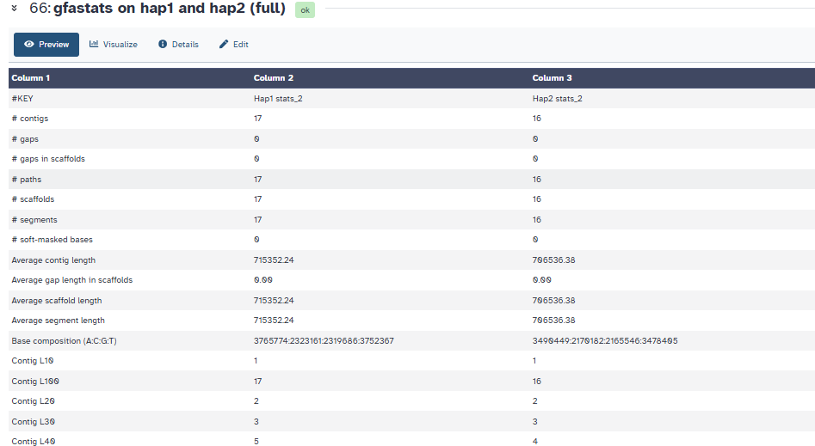

- Using Search in textfiles (grep) to extract only relevant information:
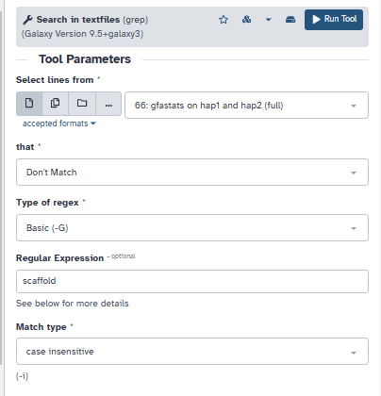
Output (without scaffold)
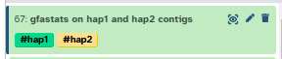
Preview:
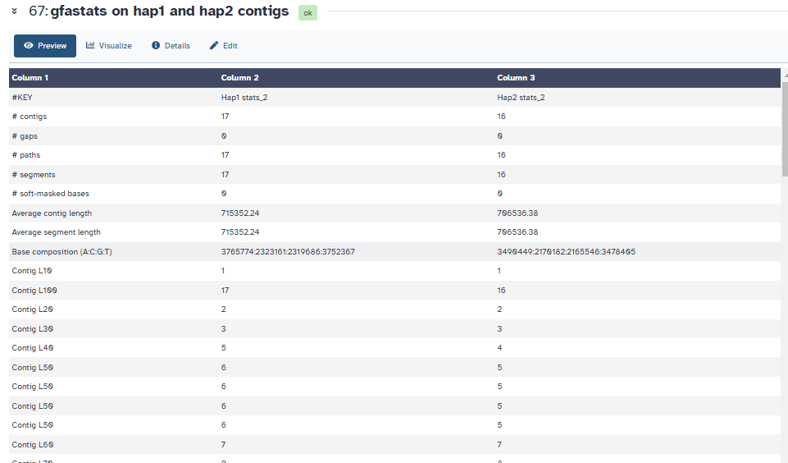
According to the report, both assemblies were quite similar; the hap1 assembly included 16 contigs, totalling ~11.3Mbp of sequence (the Total contig length statistic), while the hap2 assembly includes 17 contigs, whose total length is ~12.2Mbp. (the order is reversed between the two haplotypes):
- Assessing assembly completeness with BUSCO
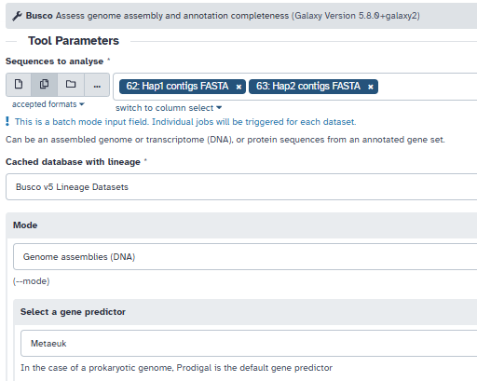
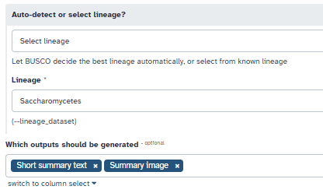

(BUSCO did not run for some reason so I’m skipping this for now)
- k-mer based evaluation with Merqury:
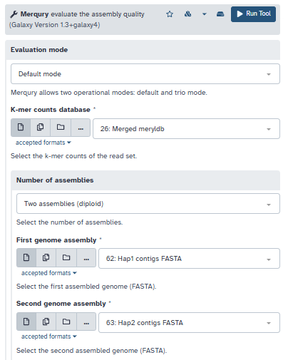
Merqury generated three collections as output: stats, plots and consensus accuracy quality value (QV) stats
The spectra-cn.ln plots:
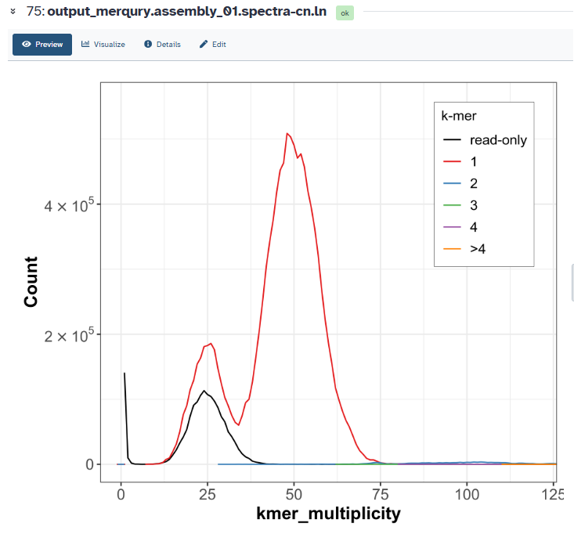
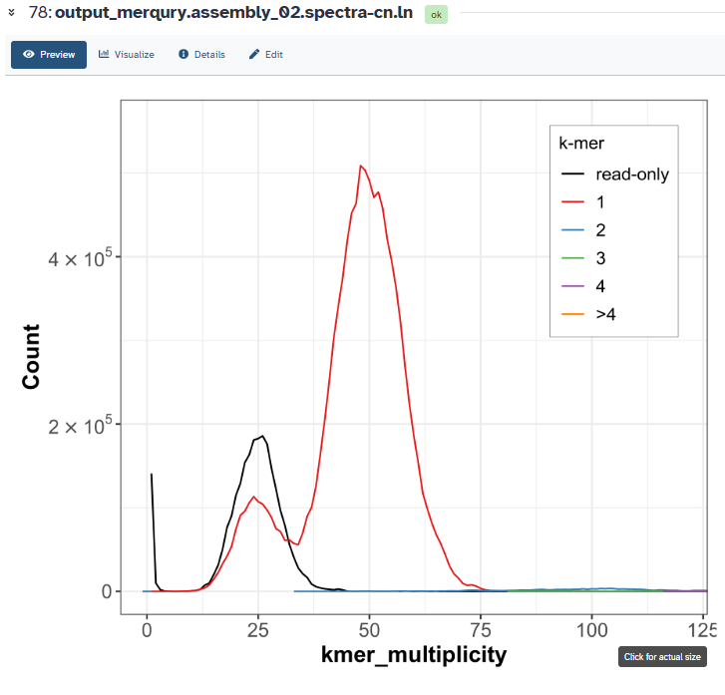
The spectra-asm.fl output:

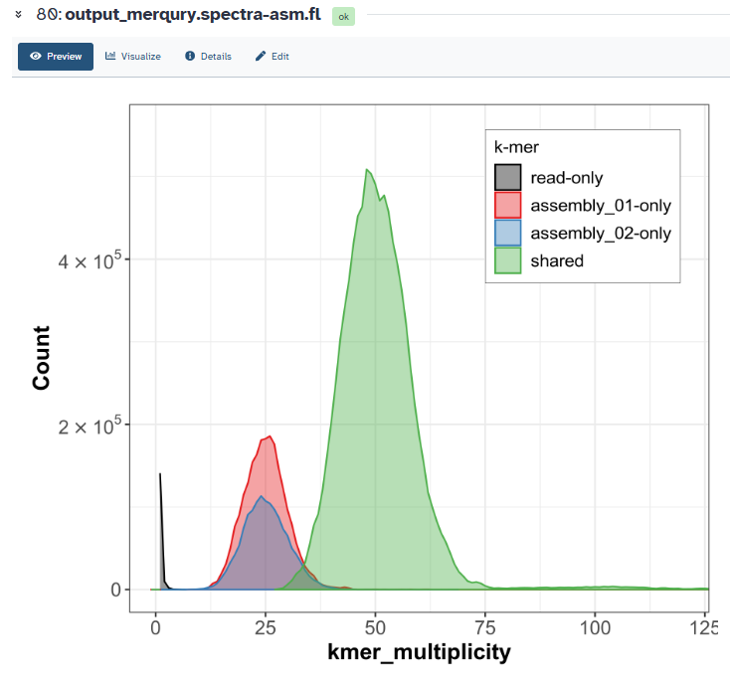
SCAFFOLDING:
- Using Bionano Hybrid Scaffold
Uploaded BioNano datasets from Zenodo and datatype was set to cmap:
https://zenodo.org/records/5887339/files/bionano.cmap
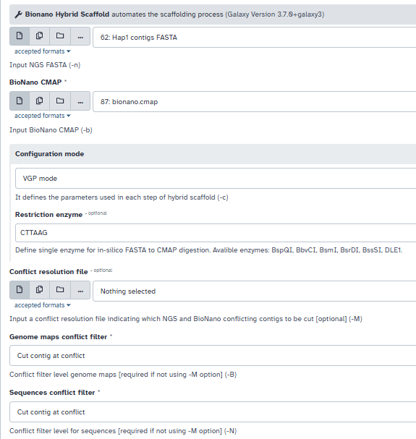

- Concatenate datasets on output of Bionano Hybrid Scaffold output:
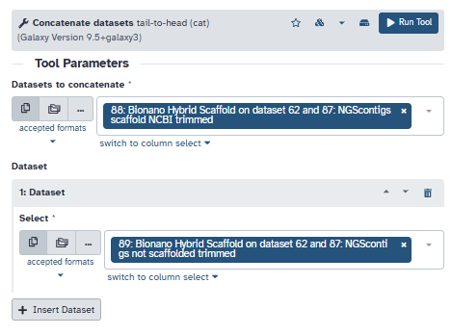
Output:
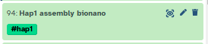
- Pre-processing by mapping Hi-C reads using BWA-MEM2 for forward and reverse reads:
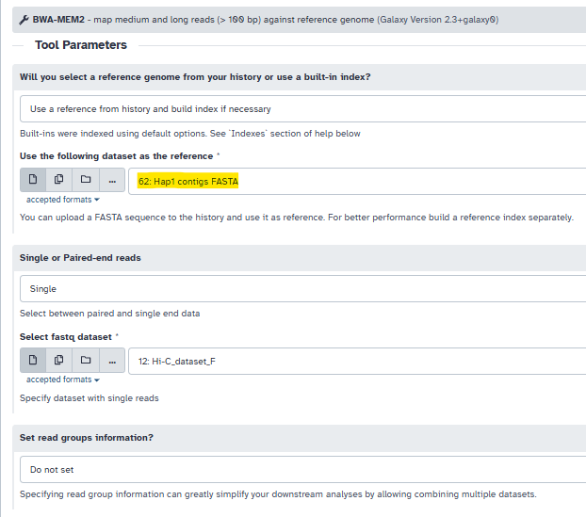
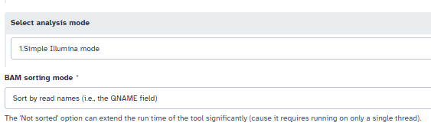
Output:
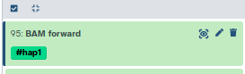
Parameters were same for both forward and reverse reads:
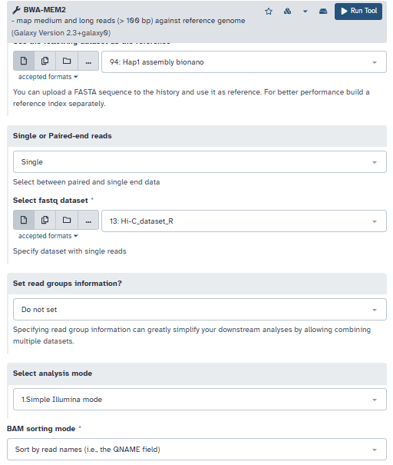
- Merging forward and reverse aligned reads using “Filter and merge”:
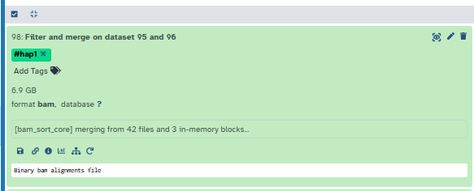
- Generating contact map with pretextmap:
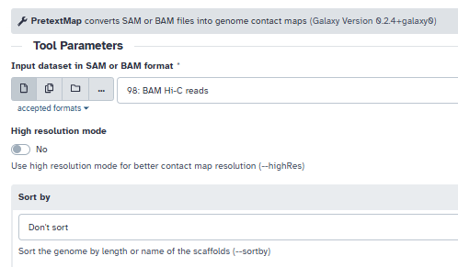
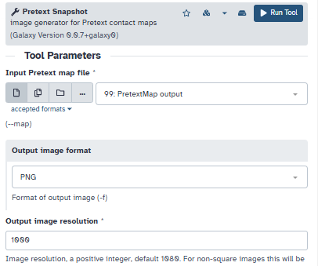
output:
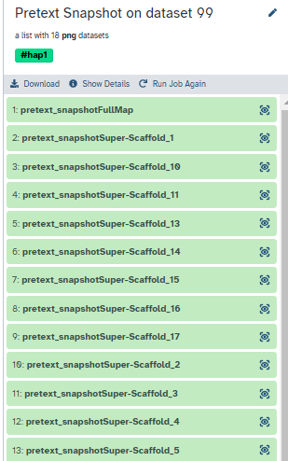
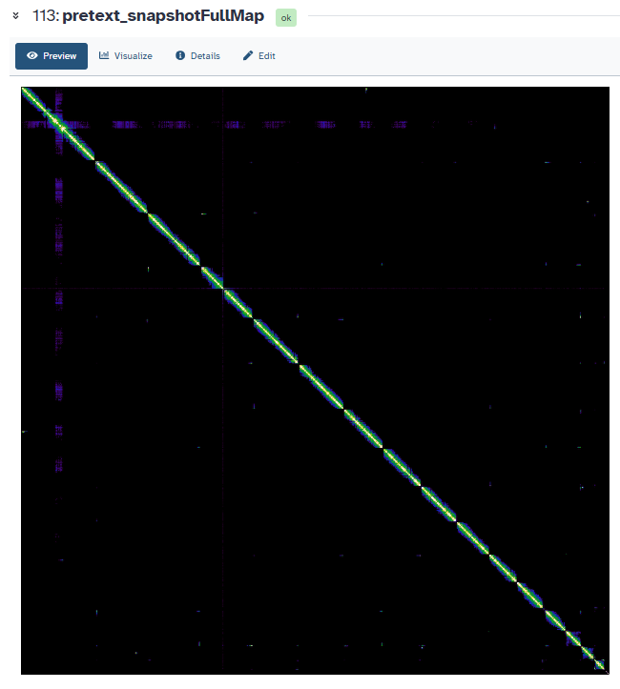

- YaHS scaffolding:
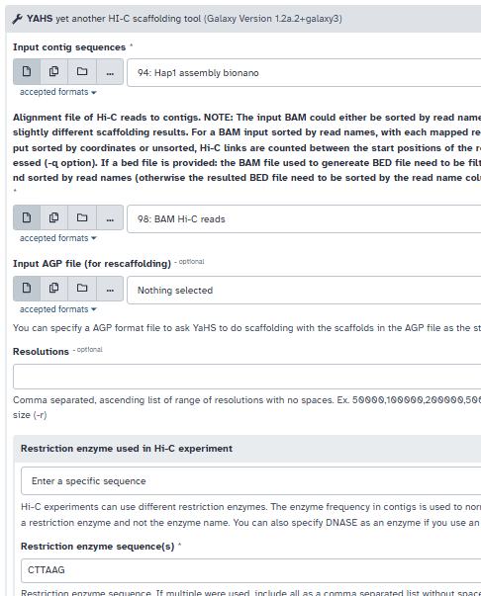
output:
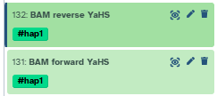

- Filter and merge the BAM forward and reverse YaHS reads:
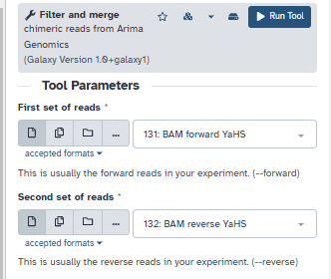
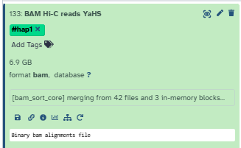
- Pretextmap:
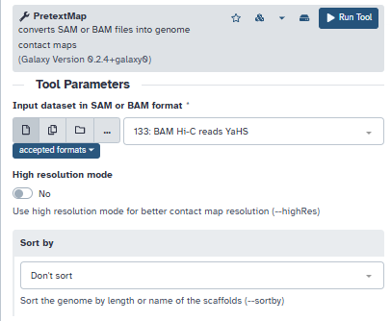

Content for the README:
- Directory structure
(need to add .txt file with zenodo links in data/, need to add this documentation pdf in docs/ after formatting it)
Initial directory structure after files download from galaxy:
results/
├── assembly/
│ ├── 'Hap1 assembly bionano.fasta'
│ ├── 'Hap1 contigs FASTA.fasta'
│ ├── 'Hap2 contigs FASTA.fasta'
│ └── 'YaHS Scaffolds FASTA (hap1).fasta'
├── busco/
│ ├── 'BUSCO hap1 - Full table.tabular'
│ ├── 'BUSCO hap1 - Short summary.txt'
│ ├── 'BUSCO hap1 - Summary image.png'
│ ├── 'BUSCO hap2 - Full table.tabular'
│ ├── 'BUSCO hap2 - Short summary.txt'
│ └── 'BUSCO hap2- Summary image.png'
├── genomescope/
│ ├── 'GenomeScope on meryldb histogram Linear plot.png'
│ ├── 'GenomeScope on meryldb histogram Log plot.png'
│ ├── 'GenomeScope on meryldb histogram Model parameters.tabular'
│ ├── 'GenomeScope on meryldb histogram Summary.txt'
│ ├── 'GenomeScope on meryldb histogram Transformed linear plot.png'
│ ├── 'GenomeScope on meryldb histogram Transformed log plot.png'
│ └── 'meryldb histogram.tabular'
├── merqury/
│ ├── 'hap1 and guest2 Merqury QV stats (using merged meryldb)'/
│ │ ├── output_merqury.assembly_01.tabular
│ │ ├── output_merqury.assembly_02.tabular
│ │ └── output_merqury.tabular
│ ├── 'hap1 and hap2 Merqury plots (using merged meryldb)'/
│ │ ├── output_merqury.assembly_01.spectra-cn.fl.png
│ │ ├── output_merqury.assembly_01.spectra-cn.ln.png
│ │ ├── output_merqury.assembly_01.spectra-cn.st.png
│ │ ├── output_merqury.assembly_02.spectra-cn.fl.png
│ │ ├── output_merqury.assembly_02.spectra-cn.ln.png
│ │ ├── output_merqury.assembly_02.spectra-cn.st.png
│ │ ├── output_merqury.spectra-asm.fl.png
│ │ ├── output_merqury.spectra-asm.ln.png
│ │ ├── output_merqury.spectra-asm.st.png
│ │ ├── output_merqury.spectra-cn.fl.png
│ │ ├── output_merqury.spectra-cn.ln.png
│ │ └── output_merqury.spectra-cn.st.png
│ └── 'hap1 and hap2 Merqury stats (using merged meryldb)'/
│ └── output_merqury.completeness.tabular
├── scaffolding/
│ ├── 'Pretext Snapshot for PretextMap output YaHS'/
│ │ ├── pretext_snapshotFullMap.png
│ │ ├── pretext_snapshotscaffold_1.png
│ │ ├── pretext_snapshotscaffold_2.png
│ │ └── ... (scaffolds 3-16)
│ └── 'Pretext Snapshot for PretextMap output of BAM Hi-C reads'/
│ ├── pretext_snapshotFullMap.png
│ ├── pretext_snapshotSuper-Scaffold_1.png
│ ├── pretext_snapshotSuper-Scaffold_2.png
│ ├── pretext_snapshotSuper-Scaffold_3.png
│ └── ... (Super-Scaffolds 4-17 + path_obj.png)
└── stats/
├── 'Hap1 stats.tabular'
├── 'Hap2 stats.tabular'
├── 'gfastats on hap1 and hap2 (full).tabular'
└── 'gfastats on hap1 and hap2 contigs.tabular'

I kept only a few representative scaffolds (scaffold 1 and 2 for both BAM Hi-C reads and YaHS). I chose to keep bionano assembly because I do intend to refer to it too.

I made a readme.md to document: my steps (briefly i.e the most important checkpoints), result descriptions and interpretations, pipeline reproducibility instructions, and the general directory structure of the repository.

I also made reference_comparison.md in results/ to compare between the final assembly with the S. cerevisiae_ S288C reference genome.

Here is the directory tree after these modifications:
genome-assembly-project
├── README.md
├── data
│ └── download_links.txt
├── docs
└── results
├── assembly
│ ├── Hap1 assembly bionano.fasta
│ ├── Hap1 contigs FASTA.fasta
│ ├── Hap2 contigs FASTA.fasta
│ └── YaHS Scaffolds FASTA (hap1).fasta
├── busco
│ ├── BUSCO hap1 - Full table.tabular
│ ├── BUSCO hap1 - Short summary.txt
│ ├── BUSCO hap1 - Summary image.png
│ ├── BUSCO hap2 - Full table.tabular
│ ├── BUSCO hap2 - Short summary.txt
│ └── BUSCO hap2- Summary image.png
├── genomescope
│ ├── GenomeScope on meryldb histogram Linear plot.png
│ ├── GenomeScope on meryldb histogram Log plot.png
│ ├── GenomeScope on meryldb histogram Model parameters.tabular
│ ├── GenomeScope on meryldb histogram Summary.txt
│ ├── GenomeScope on meryldb histogram Transformed linear plot.png
│ ├── GenomeScope on meryldb histogram Transformed log plot.png
│ └── meryldb histogram.tabular
├── merqury
│ ├── hap1 and hap2 Merqury QV stats (using merged meryldb)
│ │ ├── output_merqury.assembly_01.tabular
│ │ ├── output_merqury.assembly_02.tabular
│ │ └── output_merqury.tabular
│ ├── hap1 and hap2 Merqury plots (using merged meryldb)
│ │ ├── output_merqury.assembly_01.spectra-cn.ln.png
│ │ ├── output_merqury.assembly_02.spectra-cn.ln.png
│ │ ├── output_merqury.spectra-asm.ln.png
│ │ └── output_merqury.spectra-cn.ln.png
│ └── hap1 and hap2 Merqury stats (using merged meryldb)
│ └── output_merqury.completeness.tabular
├── reference_comparison.md
├── scaffolding
│ ├── Pretext Snapshot for PretextMap output YaHS
│ │ ├── pretext_snapshotFullMap.png
│ │ ├── pretext_snapshotscaffold_1.png
│ │ └── pretext_snapshotscaffold_2.png
│ └── Pretext Snapshot for PretextMap output of BAM Hi-C reads
│ ├── pretext_snapshotFullMap.png
│ ├── pretext_snapshotSuper-Scaffold_1.png
│ ├── pretext_snapshotSuper-Scaffold_2.png
│ └── pretext_snapshoth1tg000007l_path_obj.png
└── stats
├── Hap1 stats.tabular
├── Hap2 stats.tabular
├── gfastats on hap1 and hap2 (full).tabular
└── gfastats on hap1 and hap2 contigs.tabular

15 directories, 39 files

- Reproducibility instructions
- Execution checkpoints
- Interpretation of important files in results/
- Genomescope Summary.txt
(GenomeScope version 2.0
input file = /corral4/main/objects/e/f/c/dataset_efca5cb2-f86e-48e0-a80e-9869b6eb6ad6.dat
output directory = .
p = 2
k = 31
TESTING set to TRUE

property min max
Homozygous (aa) 99.4165% 99.4241%
Heterozygous (ab) 0.575891% 0.583546%
Genome Haploid Length 11,739,513 bp 11,747,352 bp
Genome Repeat Length 723,114 bp 723,597 bp
Genome Unique Length 11,016,399 bp 11,023,756 bp
Model Fit 92.5159% 96.5191%
Read Error Rate 0.00094319% 0.00094319%

)
Interpretation:
GenomeScope analysis estimates a haploid genome size of approximately 11.74 Mb, with the genome being highly homozygous (~99.4%) and exhibiting low heterozygosity (~0.58%). The majority of the genome is unique sequence (~11.0 Mb), with a relatively small proportion of repetitive content (~0.72 Mb). The low read error rate (~0.00094%) indicates high-quality sequencing data, while the model fit (92–96%) suggests a good agreement between the observed k-mer distribution and the inferred genome properties. Overall, these results indicate a low-complexity, well-behaved genome suitable for accurate assembly.

- Genomescope Linear plot.png
(For:
Genome size
Heterozygosity
Repeat content
Coverage)
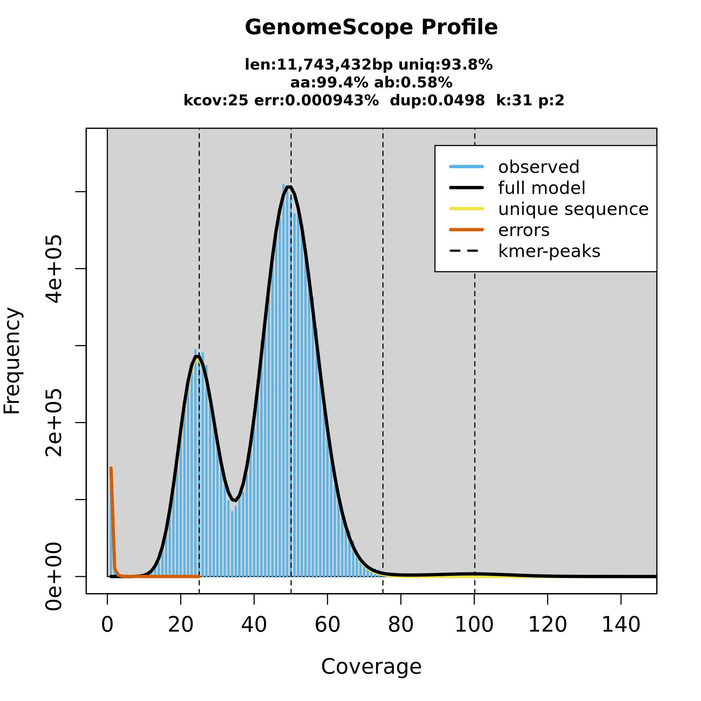
Interpretation:
The GenomeScope profile shows a well-resolved diploid genome with two clear k-mer peaks at ~25× and ~50× coverage, corresponding to heterozygous and homozygous regions respectively, confirming low but detectable heterozygosity (~0.58%). The dominance of the higher peak and the high homozygosity (~99.4%) indicate that most of the genome is uniform, which simplifies assembly. The narrow peak shapes and minimal low-coverage tail (error k-mers) reflect high sequencing quality (very low error rate), while the limited spread at higher coverage suggests low repeat content.

- Hap1 contigs FASTA.fasta

- YaHS Scaffolds FASTA (hap1).fasta
(For the reconstructed genome - the actual output of the pipeline)

- Hap1 stats.tabular
Expected genome size | 11743432
# scaffolds | 17
Total scaffold length | 12160988
Average scaffold length | 715352.24
Scaffold N50 | 923452
Scaffold auN | 904515.33
Scaffold L50 | 6
Scaffold NG50 | 923452
Scaffold auNG | 936676.78
Scaffold LG50 | 6
Largest scaffold | 1531728
Smallest scaffold | 85850
# contigs | 17
Total contig length | 12160988
Average contig length | 715352.24
Contig N50 | 923452
Contig auN | 904515.33
Contig L50 | 6
Contig NG50 | 923452
Contig auNG | 936676.78
Contig LG50 | 6
Largest contig | 1531728
Smallest contig | 85850
# gaps in scaffolds | 0
Total gap length in scaffolds | 0
Average gap length in scaffolds | 0
Gap N50 in scaffolds | 0
Gap auN in scaffolds | 0
Gap L50 in scaffolds | 0
Largest gap in scaffolds | 0
Smallest gap in scaffolds | 0
Base composition (A:C:G:T) | 3765774:2323161:2319686:3752367
GC content % | 38.18
# soft-masked bases | 0
# segments | 17
Total segment length | 12160988
Average segment length | 715352.24
# gaps | 0
# paths | 17
Scaffold N10 | 1531728
Scaffold N20 | 1091839
Scaffold N30 | 1091004
Scaffold N40 | 949013
Scaffold N50 | 923452
Scaffold N60 | 813039
Scaffold N70 | 745651
Scaffold N80 | 576535
Scaffold N90 | 439841
Scaffold N100 | 85850
Scaffold L10 | 1
Scaffold L20 | 2
Scaffold L30 | 3
Scaffold L40 | 5
Scaffold L50 | 6
Scaffold L60 | 7
Scaffold L70 | 9
Scaffold L80 | 11
Scaffold L90 | 13
Scaffold L100 | 17
Scaffold NG10 | 1531728
Scaffold NG20 | 1091839
Scaffold NG30 | 1091004
Scaffold NG40 | 1078099
Scaffold NG50 | 923452
Scaffold NG60 | 813039
Scaffold NG70 | 784311
Scaffold NG80 | 667180
Scaffold NG90 | 562559
Scaffold NG100 | 271940
Scaffold LG10 | 1
Scaffold LG20 | 2
Scaffold LG30 | 3
Scaffold LG40 | 4
Scaffold LG50 | 6
Scaffold LG60 | 7
Scaffold LG70 | 8
Scaffold LG80 | 10
Scaffold LG90 | 12
Scaffold LG100 | 15
Contig N10 | 1531728
Contig N20 | 1091839
Contig N30 | 1091004
Contig N40 | 949013
Contig N50 | 923452
Contig N60 | 813039
Contig N70 | 745651
Contig N80 | 576535
Contig N90 | 439841
Contig N100 | 85850
Contig L10 | 1
Contig L20 | 2
Contig L30 | 3
Contig L40 | 5
Contig L50 | 6
Contig L60 | 7
Contig L70 | 9
Contig L80 | 11
Contig L90 | 13
Contig L100 | 17
Contig NG10 | 1531728
Contig NG20 | 1091839
Contig NG30 | 1091004
Contig NG40 | 1078099
Contig NG50 | 923452
Contig NG60 | 813039
Contig NG70 | 784311
Contig NG80 | 667180
Contig NG90 | 562559
Contig NG100 | 271940
Contig LG10 | 1
Contig LG20 | 2
Contig LG30 | 3
Contig LG40 | 4
Contig LG50 | 6
Contig LG60 | 7
Contig LG70 | 8
Contig LG80 | 10
Contig LG90 | 12
Contig LG100 | 15
Gap N10 | 0
Gap N20 | 0
Gap N30 | 0
Gap N40 | 0
Gap N50 | 0
Gap N60 | 0
Gap N70 | 0
Gap N80 | 0
Gap N90 | 0
Gap N100 | 0
Gap L10 | 0
Gap L20 | 0
Gap L30 | 0
Gap L40 | 0
Gap L50 | 0
Gap L60 | 0
Gap L70 | 0
Gap L80 | 0
Gap L90 | 0
Gap L100 | 0
The hap1 assembly consists of 17 scaffolds with a total length of ~12.16 Mb, slightly exceeding the expected genome size (~11.74 Mb), which may indicate minor redundancy or unresolved duplicated regions. The scaffold N50 (~923 kb) and high auN (~904 kb) suggest strong contiguity, with relatively long continuous sequences and limited fragmentation. However, the inflated total length compared to expectation, combined with the slightly higher scaffold count, hints at possible residual haplotypic duplication or incomplete collapsing of homologous regions during assembly. Overall, hap1 demonstrates high continuity but may contain small structural redundancies that could affect downstream analyses if not accounted for.
- Hap2 stats.tabular
(For:
Genome size
Number of contigs
N50 (if included)
Assembly fragmentation
)
The hap2 assembly contains 16 scaffolds with a total length of ~11.30 Mb, closely matching the expected genome size and aligning well with the known chromosome count of S. cerevisiae. The scaffold N50 (~922 kb) and auN (~895 kb) are comparable to hap1, indicating similarly strong contiguity and assembly quality. Unlike hap1, the closer agreement with expected genome size suggests fewer duplicated or redundant regions, implying a cleaner and more collapsed representation of the genome. This makes hap2 a more accurate structural representation overall, likely reflecting better resolution of haplotypes and fewer assembly artifacts.

- Busco Short summary.txt
Hap1: 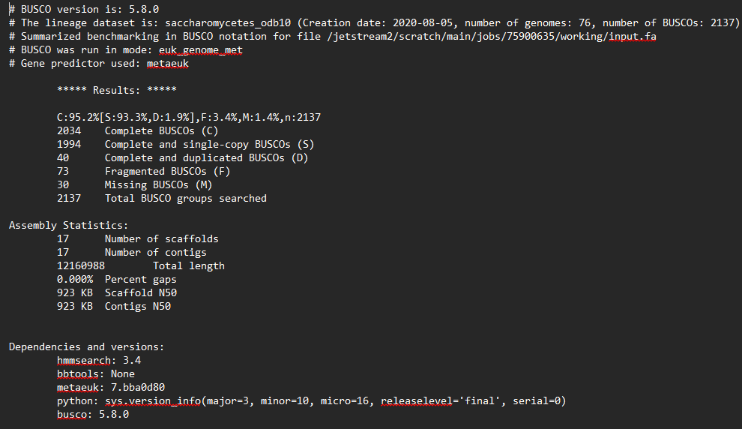

The hap1 assembly shows high completeness with 95.2% complete BUSCOs, the majority of which are single-copy (93.3%), indicating that most expected genes are accurately represented without redundancy. The low duplication rate (1.9%) suggests minimal assembly artifacts, while the small proportion of fragmented (3.4%) and missing genes (1.4%) indicates only minor gaps in gene recovery.

Hap2: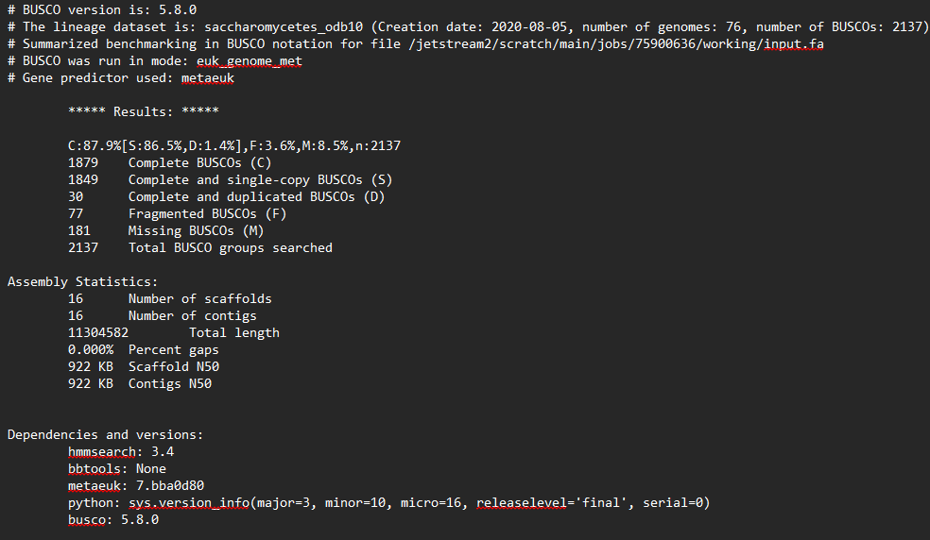
The hap2 assembly exhibits lower completeness, with 87.9% complete BUSCOs and a higher proportion of missing genes (8.5%), indicating that a notable fraction of expected gene content was not recovered. While most detected genes are single-copy (86.5%) and duplication remains low (1.4%), the elevated missing and fragmented BUSCOs (3.6%) suggest reduced assembly completeness, potentially due to collapsed regions or incomplete reconstruction. This indicates that hap2 is less complete and biologically representative compared to hap1.

- Busco Summary image.png
(For biological completeness:
% complete genes
% duplicated genes
% missing genes
)
hap1:
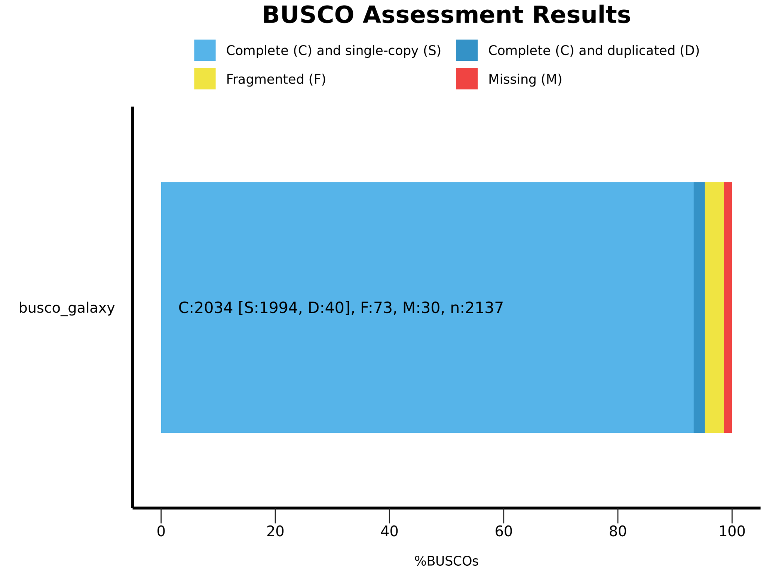

Hap2:
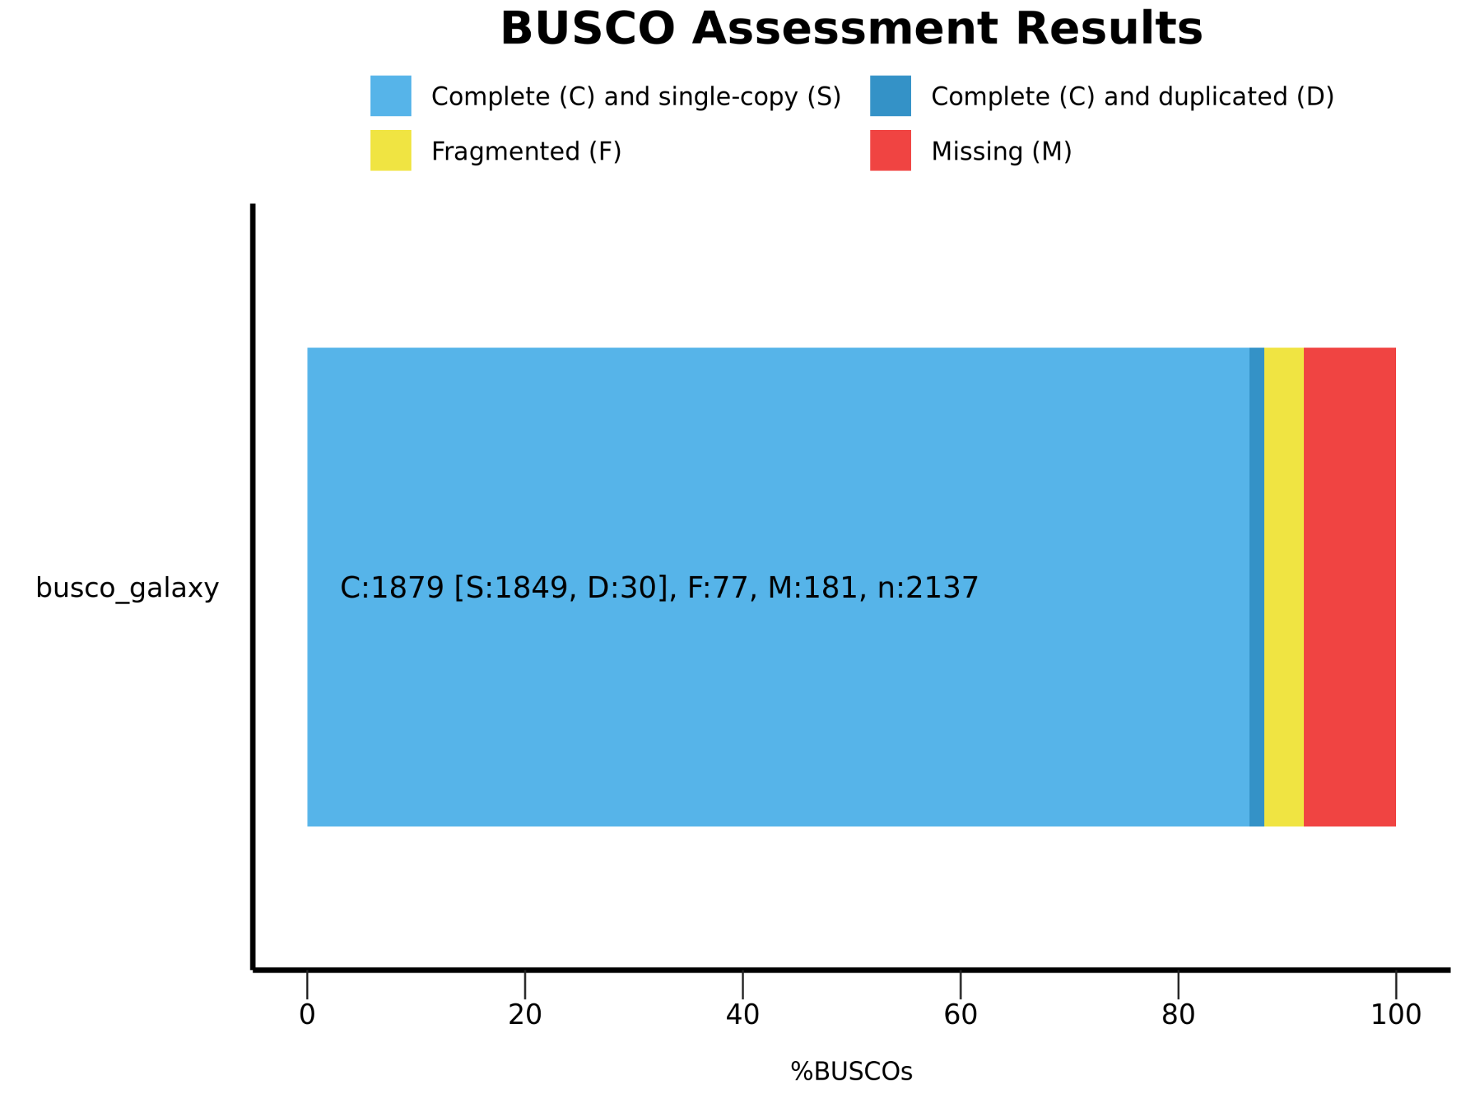

- QV stats

assembly_01 4 12160478 79.7425 1.06E-08
assembly_02 0 11304102 #NAME? 0
Both 4 23464580 82.5971 5.50E-09

The Merqury QV and completeness statistics indicate high consensus accuracy, with low error rates across both assemblies. The high proportion of shared k-mers between reads and assemblies confirms that most genomic content has been correctly reconstructed, while the small fraction of missing or erroneous k-mers suggests only minor inaccuracies.

- spectra-cn plot
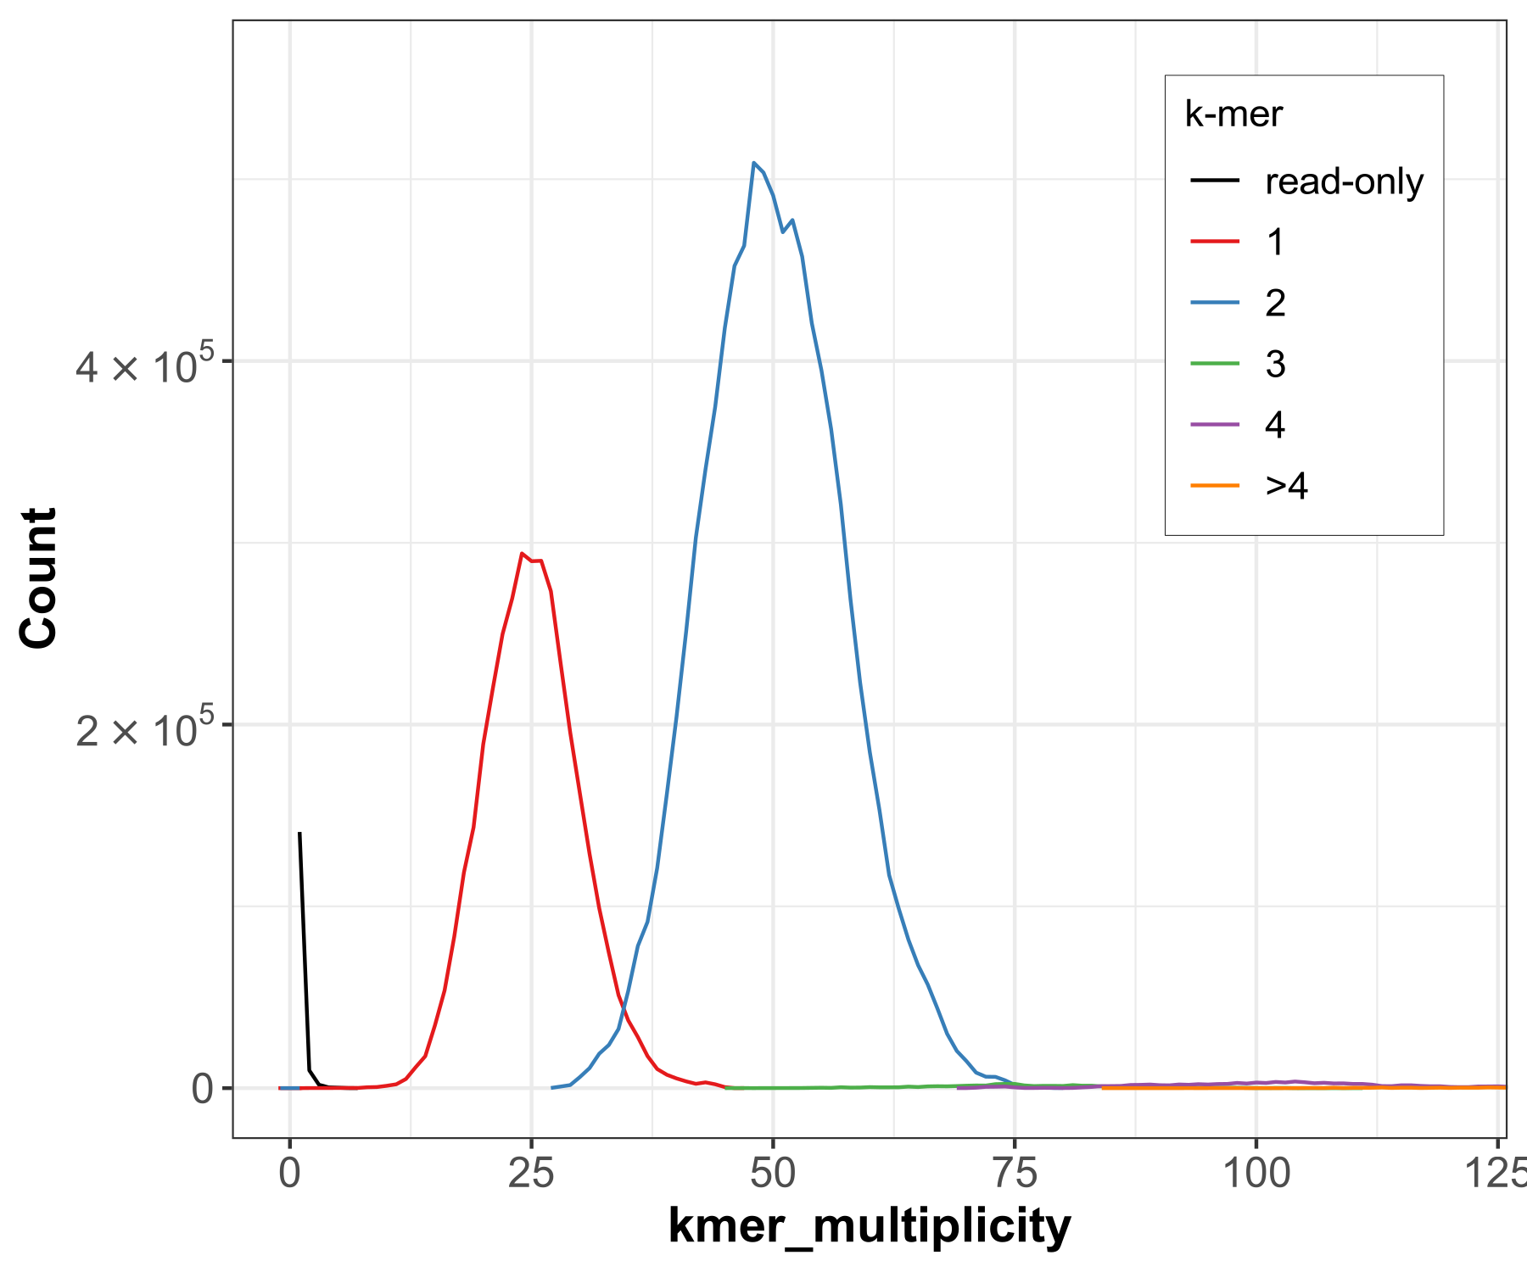
The spectra-cn plot shows that most k-mers are shared between the reads and assemblies (green peak at ~50×), indicating strong agreement and good representation of true genomic content. The smaller peaks for assembly-specific k-mers (red and blue) suggest minor differences between hap1 and hap2, likely reflecting haplotype variation or small assembly-specific errors. The low proportion of read-only k-mers (black, near low coverage) indicates minimal missing sequence, supporting overall completeness.

- spectra-asm plot
(For sequence accuracy:
Consensus accuracy (QV)
Error rate
Duplication / completeness patterns
)
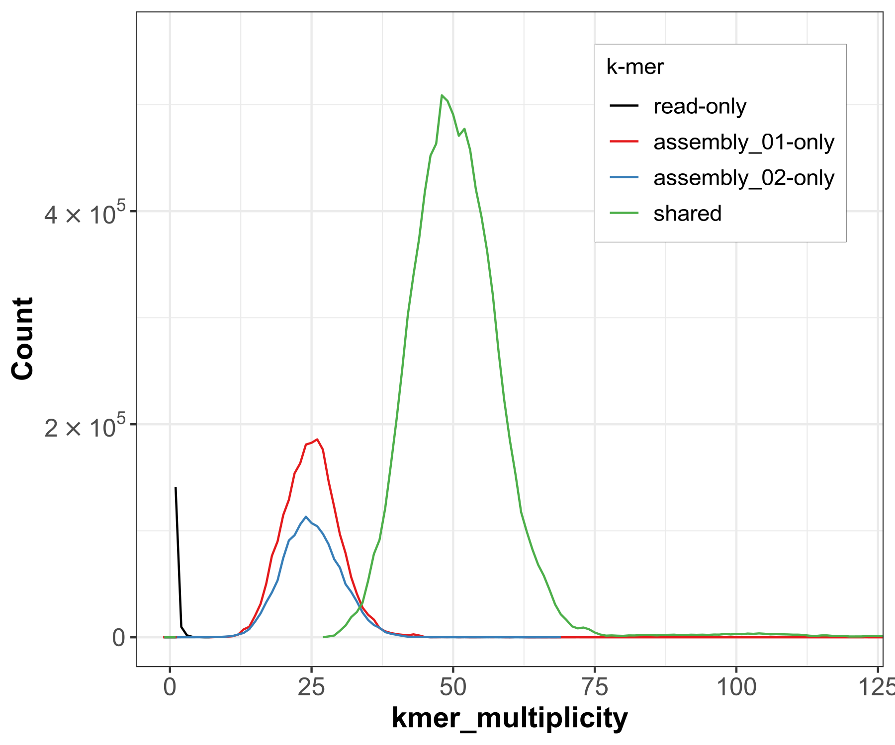

The spectra-asm plot demonstrates that the majority of k-mers fall into the expected copy number categories, with a clear separation between heterozygous (~25×) and homozygous (~50×) peaks. This indicates proper representation of diploid structure and effective haplotype resolution. The minimal presence of higher copy-number k-mers (>2) suggests low levels of artificial duplication, reinforcing that the assembly is not significantly over-expanded.

- pretext_snapshotFullMap.png (YaHS)
(For large-scale structure:
Chromosome structure
Correct contig ordering
Misassemblies (if present)
)
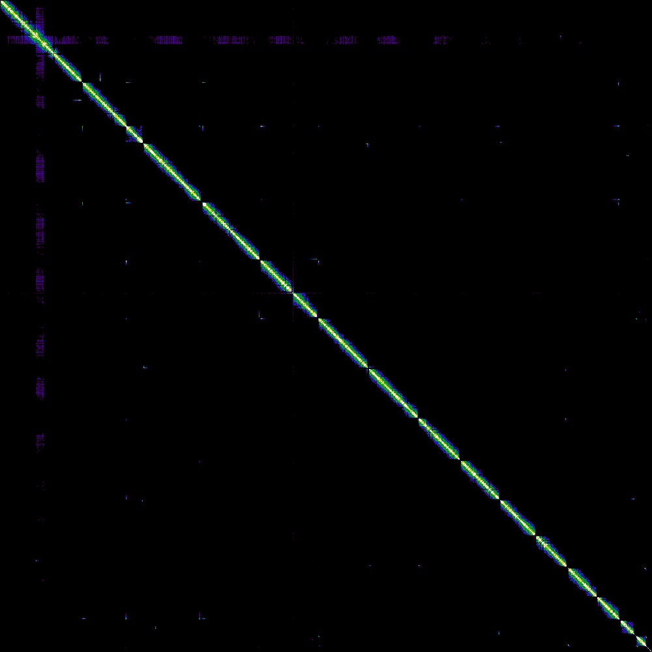
The Hi-C contact map shows a strong, continuous diagonal with well-defined square blocks along it, indicating correctly ordered and oriented scaffolds corresponding to individual chromosomes. The clear separation between blocks and absence of major off-diagonal signals suggest minimal misassemblies, as there are no strong inter-chromosomal contacts or structural inconsistencies. Overall, the pattern reflects a high-quality scaffolding result, with chromosome-scale organization and good long-range structural accuracy achieved by YaHS.

- Comparison between the final assembly with the S. cerevisiae_ S288C reference genome
(https://ftp.ncbi.nlm.nih.gov/genomes/all/GCF/000/146/045/GCF_000146045.2_R64/GCF_000146045.2_R64_assembly_stats.txt).
(Store detailed comparisons in reference_comparison.md)
(only retain a few tables here)

